Trading Indicators and its purpose and efficiency

1. Backtesting and Trading engine [pin coders] 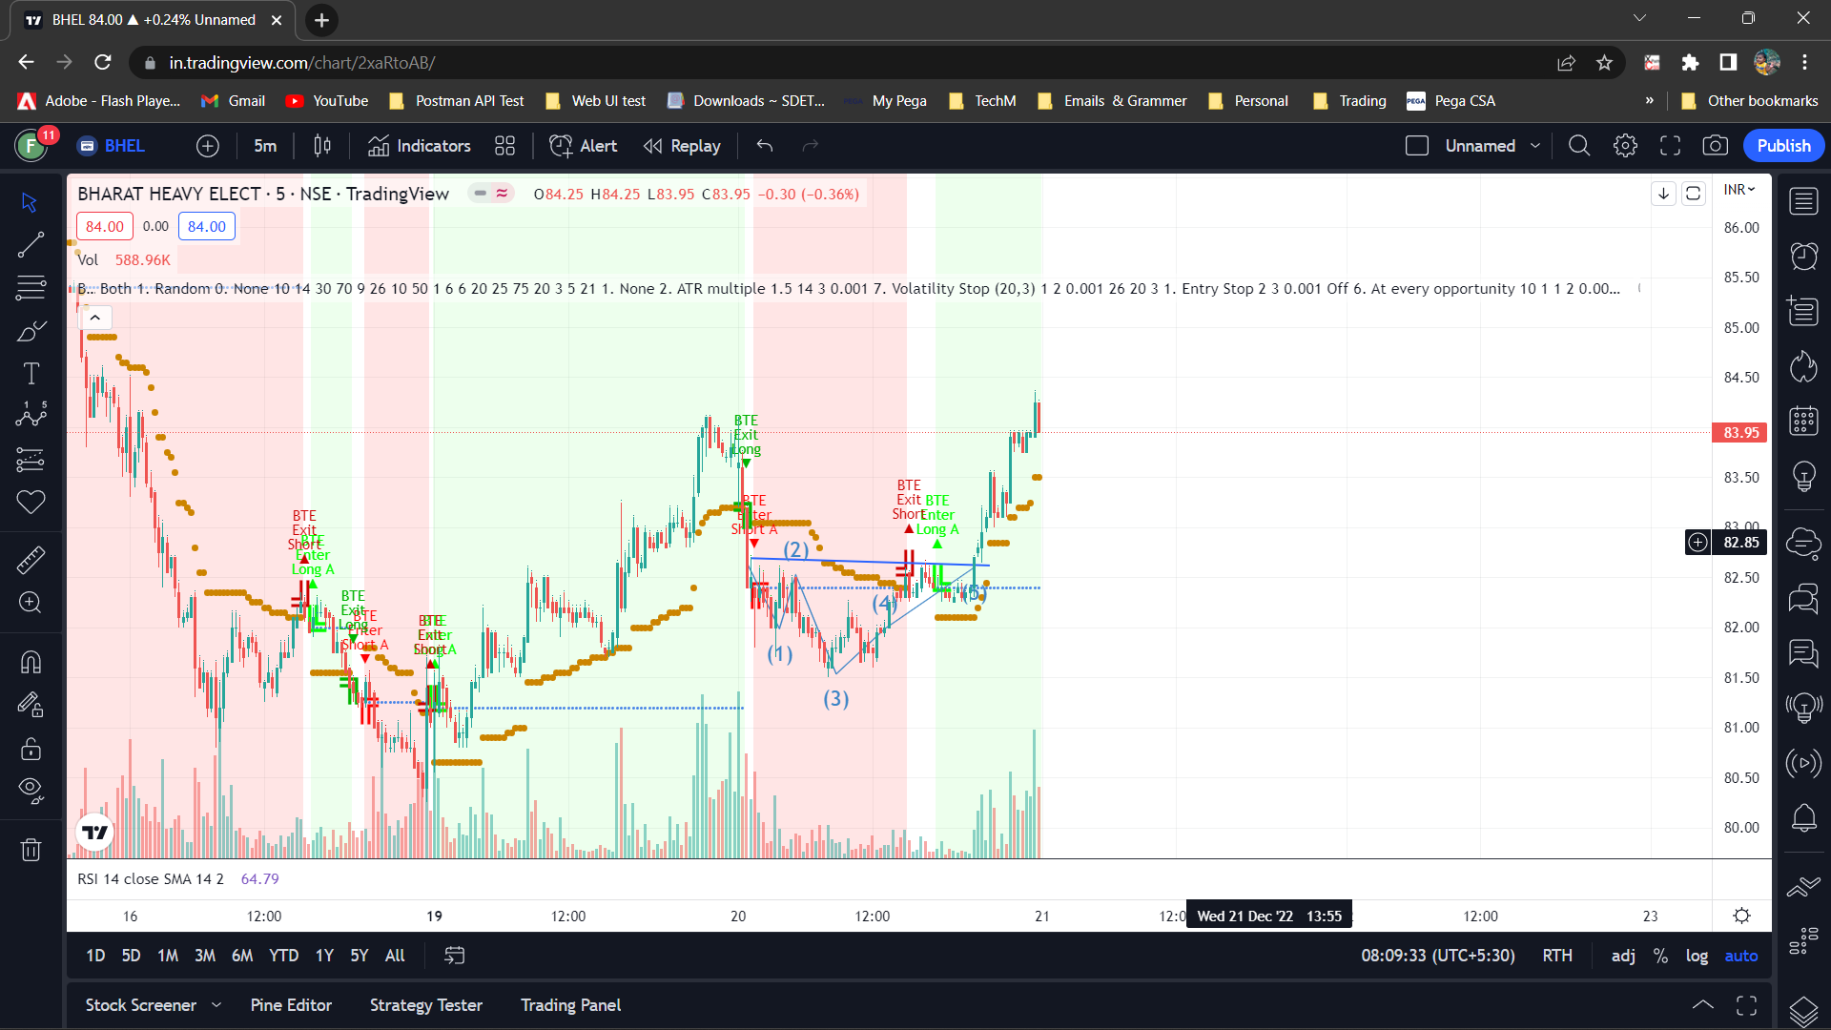­­­

Price action as in book: Fibonacci + Support/Resistant + Trendline 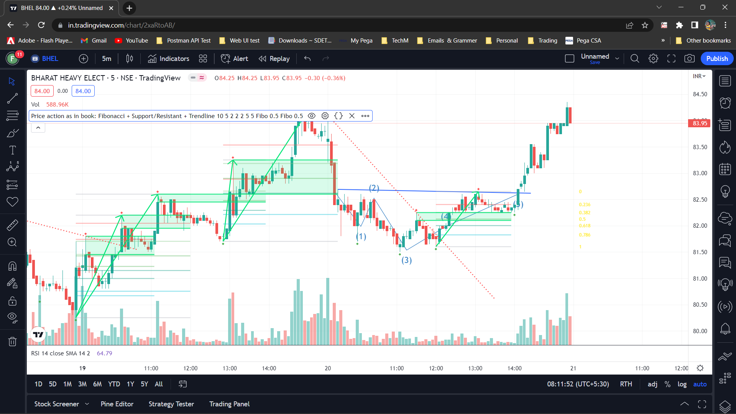3. Combination of 3 <initial to adjustment>

4. EMA cross

5. RSI – Below midline (50) downtrend & above mid (50) considered as down trend 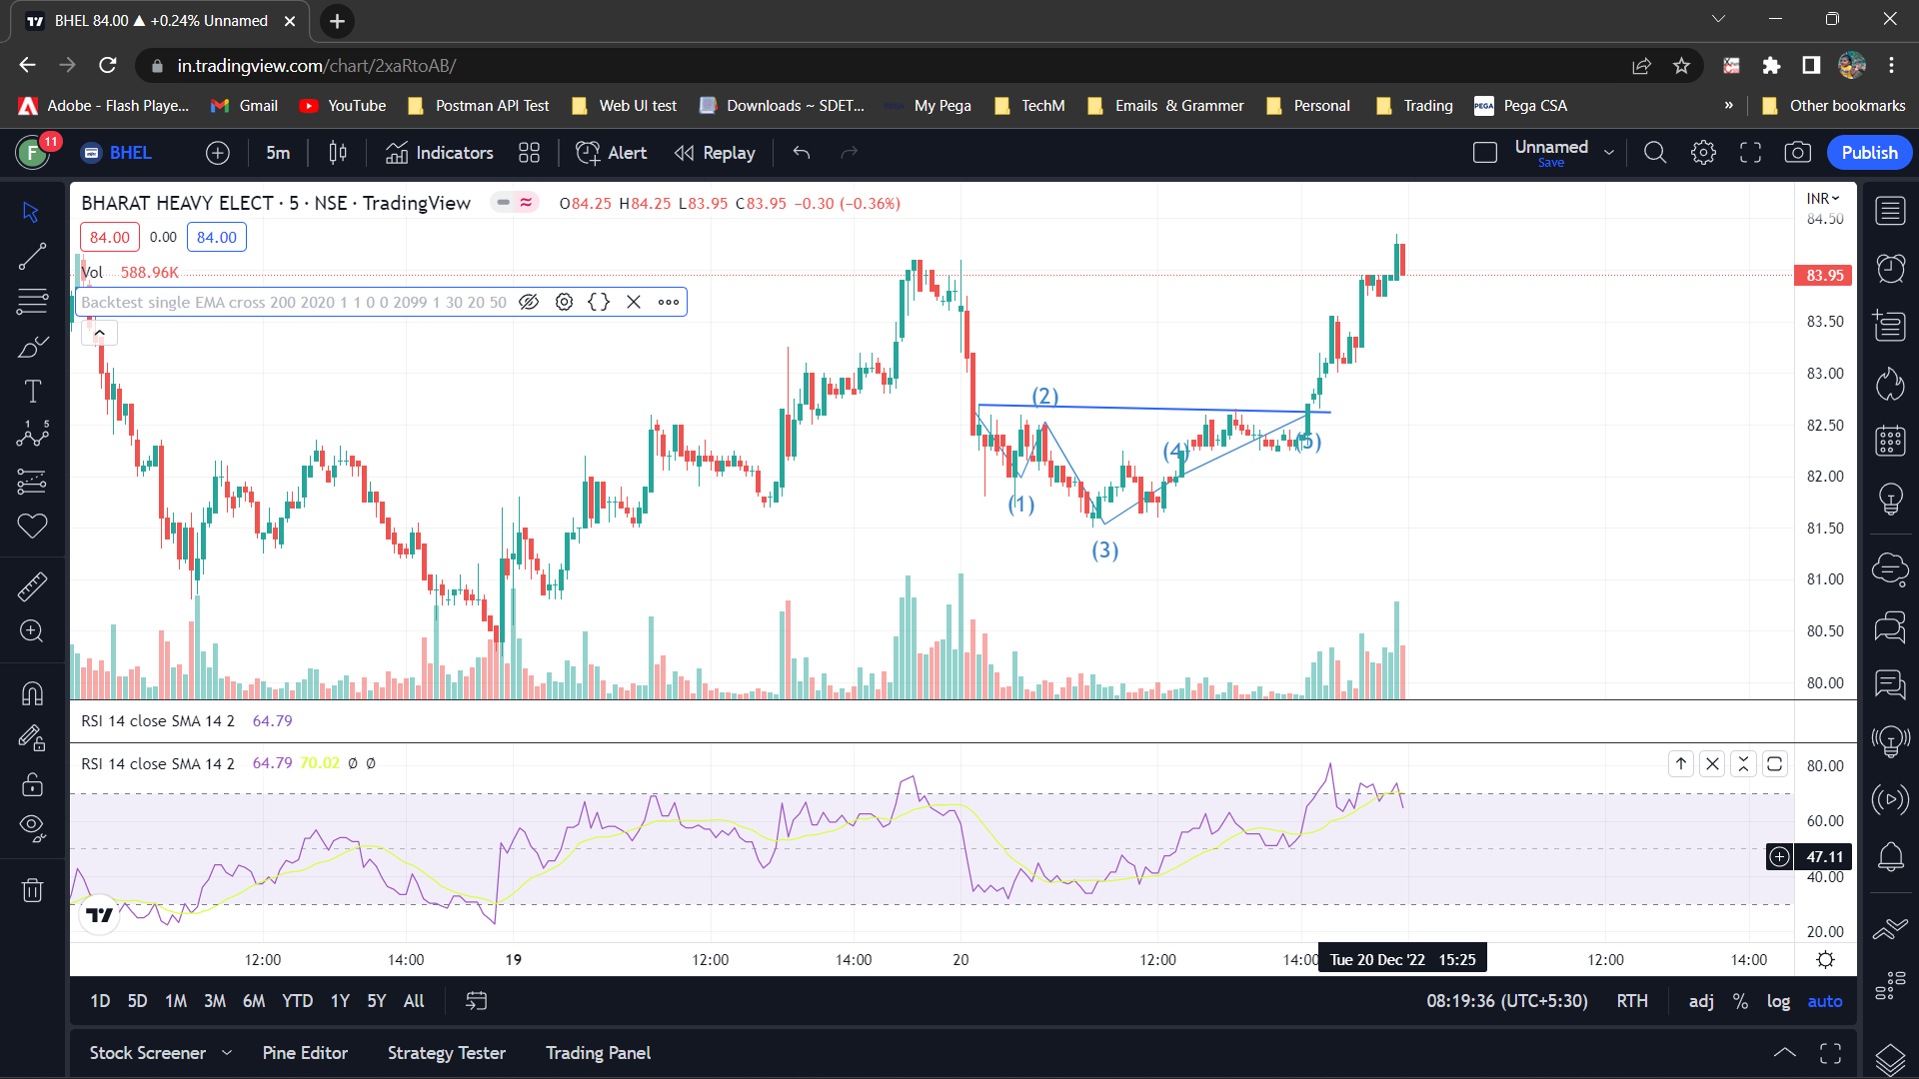

6. CPR by KGS

